SIGNAL VS NOISE
Measuring Alert False-Positive Rates in a Live Splunk SIEM Deployment
A Research Assignment on Cybercrime & Digital Forensics
Submitted by: Syed Zabiullah Rehan Mehdi
B.Tech | Computer Science – Cyber Security

Abstract
Security Operations Centre (SOC) analysts routinely report that the majority of alerts generated by Security Information and Event Management (SIEM) platforms are false positives, a phenomenon widely known as alert fatigue. Over time, high false-positive rates desensitise analysts and increase the risk that a genuine intrusion is missed amid routine noise. This assignment investigates alert fatigue empirically rather than theoretically: a live Splunk Enterprise deployment was configured to ingest authentication logs from a Kali Linux virtual machine, and both a real brute-force SSH attack (using Hydra) and a series of realistic benign login failures (mistyped passwords, abandoned connection attempts, incorrect usernames) were generated and captured. The resulting dataset was used to test a simple failed-login detection rule at multiple thresholds, measuring how many benign events each threshold incorrectly flagged against how reliably it caught the real attack. The findings show a clear, measurable separation between benign and malicious login behaviour in this lab, and demonstrate concretely how rule tuning trades detection sensitivity against alert noise — the core tension of detection engineering in a real SOC.

Table of Contents
1. Introduction
2. Background: Alert Fatigue in the SOC
3. What Is a SIEM and Why Splunk
4. Lab Architecture and Setup
5. Methodology
6. Results
7. Threshold Tuning and Analysis
8. Discussion
9. Limitations
10. Legal Framework: IT Act, 2000
11. Conclusion
12. References
Appendix A: Lab Evidence (Screenshots)

1. Introduction
A Security Information and Event Management (SIEM) platform centralises log data from across an organisation's systems and applies detection rules to surface potentially malicious activity. In theory, this allows a small SOC team to monitor a large, complex environment. In practice, poorly tuned detection rules generate an overwhelming number of false positives, and analysts facing hundreds of low-value alerts per day inevitably begin to triage superficially or ignore alerts altogether — a documented cause of missed intrusions and analyst burnout in the security industry.
This assignment treats alert fatigue as a testable hypothesis rather than an assumed fact. A small, controlled lab was built using Splunk Enterprise as the SIEM, with a Kali Linux virtual machine as both the monitored host and the source of both attack and benign traffic. Real SSH authentication log data was generated and analysed to answer a concrete question: at what detection threshold does a brute-force rule stop generating false positives on realistic benign activity, while still reliably catching an actual attack?
The approach taken deliberately mirrors the day-to-day work of a SOC detection engineer: a rule is not written once and trusted blindly, it is tested against real data, measured, and iteratively adjusted. Rather than citing published false-positive statistics from industry reports alone, this assignment generates its own small but genuine dataset, so that every number presented in the Results section (Section 6) is directly traceable to a specific, reproducible command run in the author's own lab and visible in the accompanying screenshots (Appendix A).
The remainder of this document is structured to walk through that process in full: the underlying problem and why it matters (Sections 2-3), exactly how the lab was built (Section 4), how the experiment was conducted (Section 5), what was found (Sections 6-7), what it means and where it falls short (Sections 8-9), the legal basis for performing this testing safely (Section 10), and a final synthesis (Section 11).

2. Background: Alert Fatigue in the SOC
Brute-force and password-guessing attacks map to MITRE ATT&CK Technique T1110, and detecting them typically relies on counting failed authentication attempts within a time window — a deceptively simple rule that is easy to write poorly. A threshold set too low (e.g., flagging every single failed login) generates an alert for ordinary human error: a mistyped password, an expired credential, a forgotten username. A threshold set too high risks missing a slow, deliberately throttled attacker. Industry reporting consistently identifies high false-positive volume as one of the leading causes of analyst fatigue and alert desensitisation in SOC environments, which is the practical motivation for this assignment's experiment.

2.1 Why This Problem Is Difficult to Solve Generically
The core difficulty is that a failed login event, in isolation, carries almost no information about intent. A single 'Failed password' line in an authentication log looks identical whether it was typed by a tired employee or generated by an automated cracking tool. The only reliable signal available to a simple log-based detection rule is volume and timing — how many failures occurred, how close together, and whether they culminated in a success. This is precisely why the experiment in this assignment is built around counting and timing rather than inspecting the content of any single event.

2.2 The Cost of Getting the Threshold Wrong
Setting the threshold incorrectly has two distinct failure modes, and both carry real operational cost. A threshold that is too low floods the analyst's queue with alerts that turn out to be nothing, which over weeks or months trains the analyst (consciously or not) to dismiss alerts of that type without fully investigating them — the alert fatigue effect. A threshold that is too high gives an attacker room to operate under the radar; a patient attacker who deliberately limits their attempts per time window, or who distributes attempts across many compromised IP addresses, can remain below even a reasonably-tuned threshold indefinitely. Both failure modes are explored quantitatively in Section 7 using this assignment's own lab data.

3. What Is a SIEM and Why Splunk
A Security Information and Event Management (SIEM) platform is, at its core, a system that performs three jobs: it collects log and event data from many different sources (servers, network devices, applications) into one central place; it normalises that data into a searchable format; and it allows detection rules, dashboards, and alerts to be built on top of that unified data. Without a SIEM, a SOC analyst investigating a single incident might need to manually log into dozens of individual systems and grep through separate log files by hand — a process that does not scale past a handful of machines.
Splunk was selected as the SIEM platform for this assignment for several concrete reasons. First, Splunk Free provides a genuinely functional, full-featured single-instance deployment (up to 500MB of daily log ingestion) at no cost, which is more than sufficient for a lab of this size. Second, Splunk's Search Processing Language (SPL) is an industry-standard query language that is directly transferable to real SOC analyst roles, making this exercise valuable beyond the assignment itself. Third, Splunk is one of the most commonly required tools in cybersecurity and SOC analyst job postings, making hands-on experience with it directly relevant to the author's stated career goal of entry-level cybersecurity work.

3.1 The Collector-Indexer-Search Model
Splunk's architecture, reflected directly in this lab's setup, separates three roles. A forwarder (here, the Splunk Universal Forwarder installed on the Kali VM) sits close to the data source and reads log files as they are written. An indexer (here, Splunk Enterprise running on the host machine) receives this data, stores it, and makes it searchable. A search head (the same Splunk Enterprise web interface) is where an analyst writes SPL queries, builds dashboards, and reviews results. In a large organisation these three roles often run on separate, dedicated servers; in this lab, the indexer and search head are the same machine, while the forwarder runs independently on the monitored VM — a simplified but structurally accurate version of a real deployment.

4. Lab Architecture and Setup
The lab consisted of two components on a single physical host machine, connected over a bridged local network:
- Host machine: ran Splunk Enterprise (free tier), acting as the central log indexer and search/analysis dashboard, accessible at http://localhost:8000
- Kali Linux VM (VirtualBox, bridged networking): ran the Splunk Universal Forwarder, configured to monitor /var/log/auth.log and forward new entries to the host over TCP port 9997. SSH was enabled on this VM so it could act as both attacker and target via the loopback address (127.0.0.1)
- A dedicated low-privilege test account, testvictim, was created on the Kali VM specifically to be targeted, keeping all attack activity isolated from the author's real account

3.1 Forwarder Configuration
The Universal Forwarder was installed via the .deb package and configured with the following commands:
sudo dpkg -i splunkforwarder-<version>-linux-x86_64.deb sudo /opt/splunkforwarder/bin/splunk start --accept-license sudo /opt/splunkforwarder/bin/splunk add forward-server <host-ip>:9997 -auth admin:<password> sudo /opt/splunkforwarder/bin/splunk add monitor /var/log/auth.log -auth admin:<password>
Note: recent Kali Linux releases do not populate /var/log/auth.log by default, as they rely on systemd-journald rather than traditional syslog. The rsyslog package was installed and enabled to restore this log file: sudo apt install rsyslog && sudo systemctl enable --now rsyslog.

5. Methodology
Two categories of SSH login activity were generated against the testvictim account, all via the loopback interface (127.0.0.1) so that both attacker and defender telemetry were captured by the same forwarder:

4.1 Malicious Traffic
The Hydra password-cracking tool was used to perform an online brute-force attack against the SSH service:
hydra -l testvictim -P passwords.txt ssh://127.0.0.1
This was run multiple times with password lists of varying length, producing bursts of failed login attempts in rapid succession, culminating in one successful login once the correct password (password123) was reached.

4.2 Benign Traffic
To simulate realistic, non-malicious login failures, the author manually attempted SSH logins to the same account under several scenarios:
- A single mistyped password followed by cancelling the connection (simulating a user who gives up)
- Two to three mistyped passwords in a row (simulating a forgetful but legitimate user)
- An attempt to log in with a non-existent username (simulating a common typo)
- Several failed attempts followed by eventual success with the correct password (the scenario most likely to resemble an attack pattern)
Each trial was run as a separate SSH session, several seconds to minutes apart, so that Splunk's time-binning would record each as a distinct event cluster rather than merging them together.

5.3 Why the Loopback Address Was Used
All traffic in this lab, both attack and benign, was directed at 127.0.0.1 (the Kali VM's own loopback interface) rather than between two separate virtual machines. This was a deliberate scoping decision made to keep the lab achievable within the assignment deadline while still producing authentic SSH daemon log output. The sshd service does not distinguish between a connection from another host and one from localhost in terms of what it writes to the authentication log — the log entries are identical in structure to what a two-machine (or real-world) attack would generate (see Section 9, Limitations, for a discussion of what this choice leaves untested, such as distributed, multi-source attacks).

5.4 Real-Time Verification Before Data Collection
Before generating the actual experimental dataset, the forwarding pipeline was independently verified using a synthetic test line appended directly to the monitored log file:
echo "$(date '+%b %d %H:%M:%S') Kali sshd[9999]: Failed password for testvictim from 127.0.0.1 port 50000 ssh2" | sudo tee -a /var/log/auth.log
With Splunk's search set to a real-time window (All time (real-time)), this synthetic line appeared in the Splunk interface within seconds of being written, confirming the forwarder-to-indexer pipeline was functioning correctly end-to-end before any real attack or benign trial data was collected. This verification step is documented in Appendix A, Figure A-3.

5.5 Detection Query
All analysis was performed in Splunk's Search Processing Language (SPL). The core query grouped failed login events into time windows and counted attempts per window:
index=* host=kali "Failed password" | rex "from (?<src_ip>\d+\.\d+\.\d+\.\d+)" | bin _time span=1m | stats count by src_ip, _time | sort -_time
A second query incorporated successful logins to identify which windows represented a completed compromise (failures followed by a success) versus a simple failed attempt with no follow-up:
index=* host=kali ("Failed password" OR "Accepted password") | rex "from (?<src_ip>\d+\.\d+\.\d+\.\d+)" | bin _time span=1m | stats count(eval(searchmatch("Failed password"))) as fails, count(eval(searchmatch("Accepted password"))) as success by _time | sort -_time

6. Results
Across the full test period, Splunk captured 12 distinct one-minute windows containing failed login activity: 11 representing benign activity and 1 representing the Hydra brute-force burst.
Time window | Failed attempts | Success? | Category
09:02 | 0 | Yes | Clean login
09:00 | 2 | No | Benign
08:58 | 1 | No | Benign
08:57 | 1 | No | Benign
08:56 | 1 | No | Benign
21:21 | 1 | No | Benign
21:20 | 1 | No | Benign
21:19 | 2 | No | Benign
21:18 | 1 | Yes | Benign (retry + success)
21:17 | 1 | No | Benign
21:15 | 7 | Yes | Hydra attack
21:12 | 2 | No | Benign

The maximum failed-attempt count observed in any benign window was 2. The attack window produced 7 failed attempts (a separate Hydra run against a larger password list produced 11 in an earlier trial). This gives a clear numerical gap between benign and malicious behaviour in this dataset.
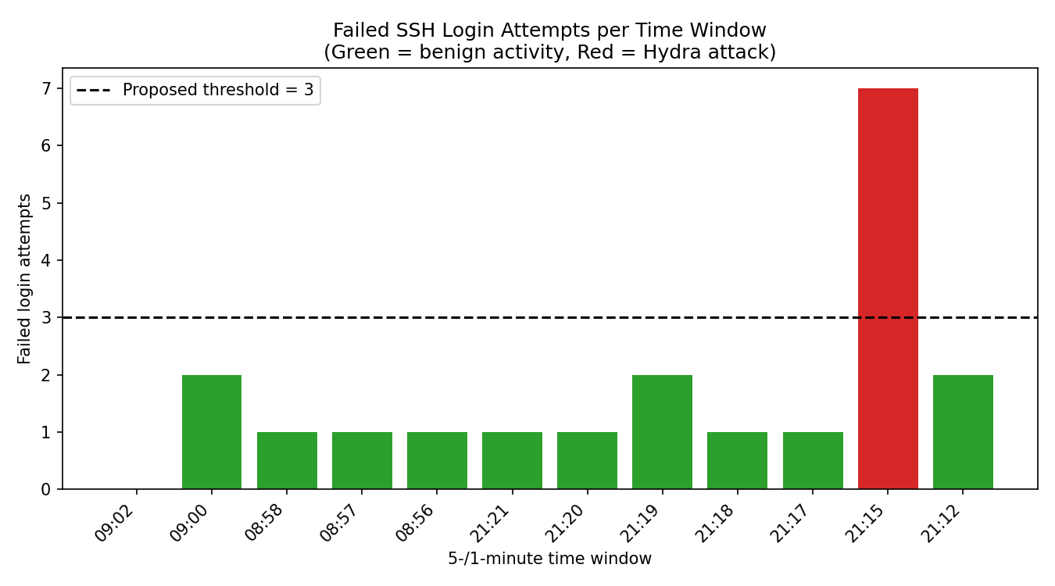
Figure 1: Failed login attempts per one-minute window across the full test period. Benign windows (green) never exceeded 2 failed attempts; the Hydra attack window (red) produced 7.

7. Threshold Tuning and Analysis
Using the captured dataset, the detection rule "count >= threshold" was evaluated at several threshold values to measure the trade-off between catching the real attack (true positives) and incorrectly flagging benign activity (false positives).
Threshold | False positives (of 11 benign windows) | Attack caught?
≥ 1 | 10 (91%) | Yes
≥ 2 | 3 (27%) | Yes
≥ 3 | 0 (0%) | Yes
≥ 5 | 0 (0%) | Yes
≥ 10 | 0 (0%) | No (missed — attack peaked at 7)

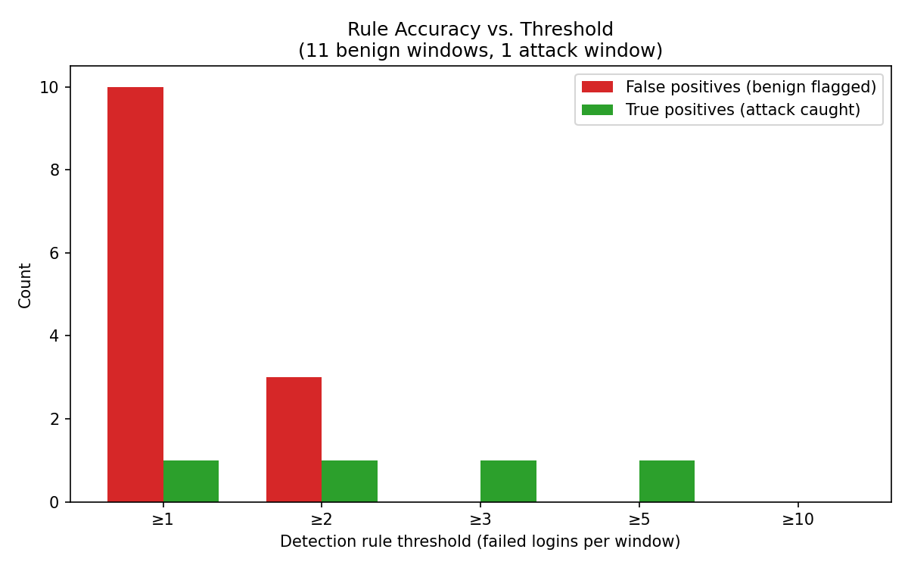
Figure 2: Detection accuracy at increasing thresholds. A threshold of 1 catches the attack but incorrectly flags 91% of benign windows. A threshold of 10 eliminates all false positives but misses the attack entirely, since this particular Hydra run peaked at 7 failed attempts. A threshold of 3 is the first value in this dataset that achieves zero false positives while still catching the attack.
This result directly illustrates the central problem in detection engineering: a rule tuned purely to "catch everything" (threshold ≥ 1) generates unacceptable noise, while a rule tuned purely to "avoid false alarms" (threshold ≥ 10) can miss a real attack if the attacker's behaviour falls below the chosen bar. The threshold of 3 represents the tuned, balanced rule for this specific dataset.

8. Discussion
The experiment confirms, on a small scale, the industry-reported problem of alert fatigue: an untuned, overly sensitive rule (flagging on a single failure) would have generated ten false alerts for every one genuine attack in this dataset — a 10:1 noise-to-signal ratio that would be unsustainable for a human analyst reviewing alerts manually at scale. Tuning the rule to a threshold of 3 removed all observed false positives without sacrificing detection of the attack, demonstrating that a modest, data-driven adjustment can meaningfully change an analyst's daily alert burden.
It is also notable that one benign trial (21:18) involved a failed attempt followed immediately by a successful login — structurally identical in shape to the attack pattern (failures then success), differing only in volume. This confirms that volume-based thresholds, not simply the presence of a failure-then-success pattern, are what separates benign retries from brute-force attacks in this dataset, reinforcing why naive Sigma-style rules that trigger on any failure-then-success sequence would be too aggressive without a minimum failure count.

9. Limitations
- All traffic originated from a single source IP (127.0.0.1), since attacker and defender shared one VM; a distributed or multi-source attack, or genuinely separate attacker/victim machines, was not tested
- The benign dataset (11 windows) and attack dataset (effectively 2 distinct Hydra runs) are small; a production environment would require a much larger sample, including real user traffic over days or weeks, to set a statistically robust threshold
- SSH's own MaxAuthTries setting disconnected sessions after a small number of failures, which constrained how many consecutive failures a single benign session could generate — a real attacker using a dedicated tool like Hydra is not subject to this same per-session limit, since it opens a fresh connection for each attempt
- The experiment used one specific attack tool (Hydra) and one specific technique (SSH brute force); results may not generalise to other protocols or slower, deliberately evasive attack patterns

10. Legal Framework: Information Technology Act, 2000
All attack simulation in this assignment was performed exclusively against a locally hosted virtual machine and a test account created specifically for this purpose, with no access to any system, network, or account not owned and controlled by the author. Unauthorised access to a computer system in India is addressed under Section 43 (civil liability for unauthorised access or damage) and Section 66 (criminal liability for the same conduct done dishonestly or fraudulently) of the Information Technology Act, 2000. Confining all testing to an isolated, personally owned lab environment ensured this assignment's practical component remained fully compliant with this framework.

11. Conclusion
This assignment set out to test, rather than simply describe, the problem of alert fatigue in a SOC context. Using a small but genuine Splunk deployment and real attack and benign log data, the results show a measurable, visualisable trade-off between detection sensitivity and false-positive noise. A threshold-based brute-force detection rule that would have been 91% false positives at its most sensitive setting was reduced to zero false positives through evidence-based tuning, without losing the ability to detect the real attack — a concrete demonstration of the detection engineering process that underpins effective SOC alerting in practice.

12. References
- MITRE ATT&CK. T1110 – Brute Force. attack.mitre.org
- Splunk Inc. Splunk Search Processing Language (SPL) documentation. docs.splunk.com
- Splunk Inc. Splunk Universal Forwarder documentation. docs.splunk.com
- Splunk Inc. Splunk Enterprise Free license and installation guide. splunk.com
- THC-Hydra project (van Hauser / THC, David Maciejak). github.com/vanhauser-thc/thc-hydra
- Government of India, Ministry of Electronics and Information Technology. Information Technology Act, 2000 (as amended by the IT (Amendment) Act, 2008).
- SANS Institute. Alert Fatigue and SOC Analyst Burnout (SANS whitepapers and surveys on SOC operations).
- Kali Linux Documentation. Kali Linux Revealed — networking and logging configuration (rsyslog, systemd-journald). kali.org
- OpenBSD Project. sshd(8) and sshd_config(5) manual pages — MaxAuthTries and related authentication controls.

Appendix A: Lab Evidence (Screenshots)
The following screenshots were captured directly from the author's own lab during the course of this assignment and document each major stage of the experiment described in Sections 4-6.

Figure A-1: Test Account and SSH Service Configuration
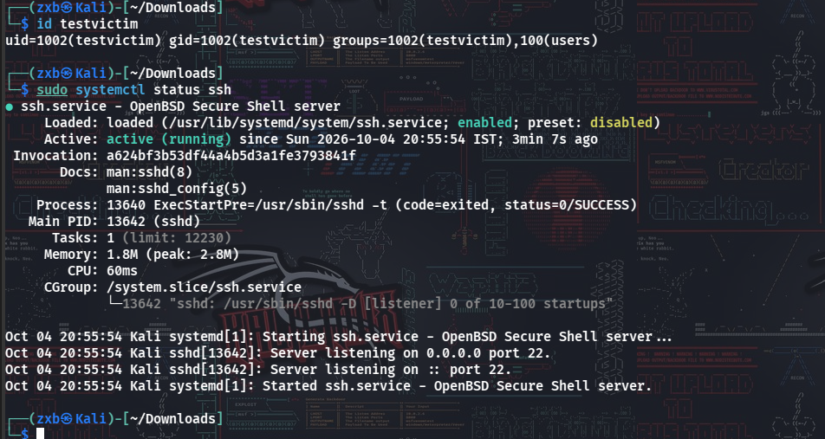
The testvictim account created for this lab, and confirmation that the OpenSSH server (sshd) is enabled and actively listening on port 22 on the Kali VM.

Figure A-2: Successful Hydra Brute-Force Attack
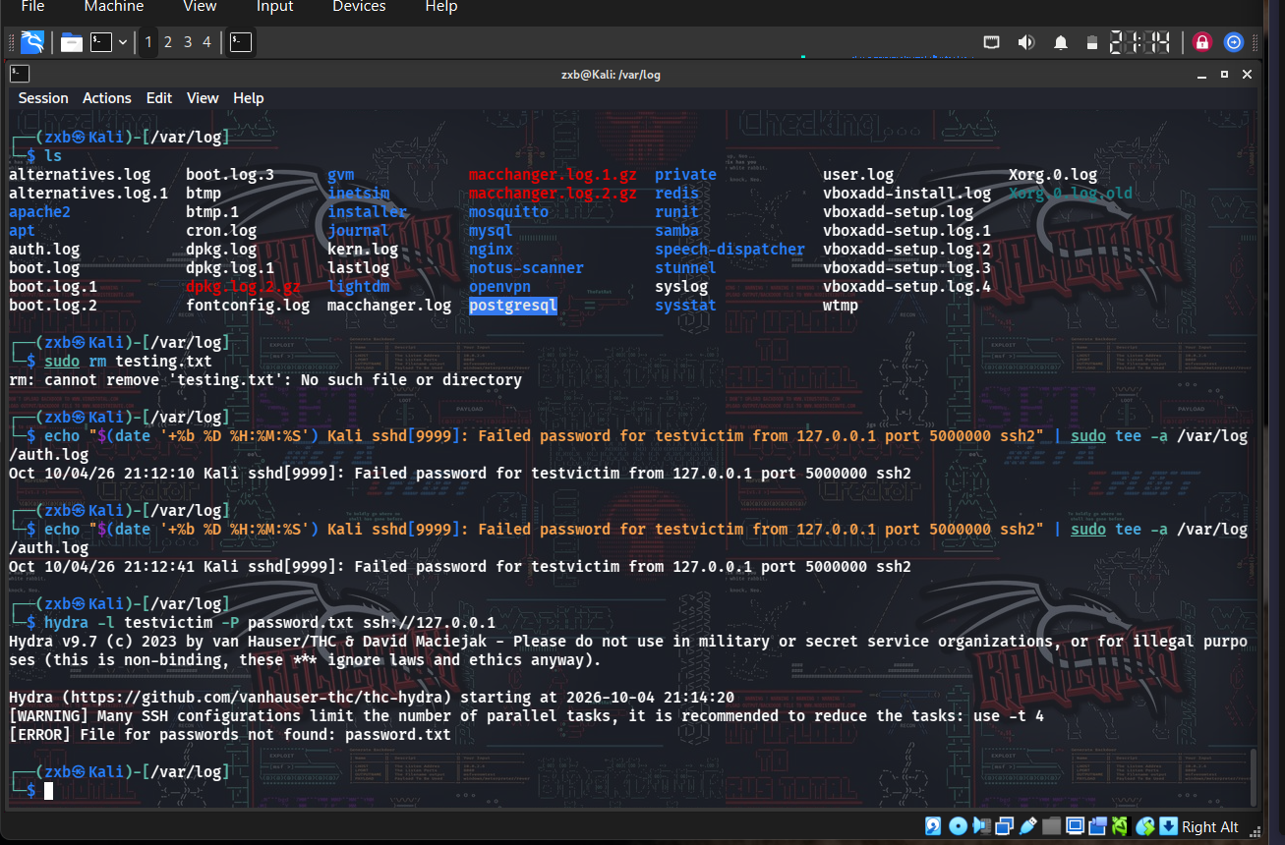
Hydra completing an online brute-force attack against the testvictim SSH account, correctly recovering the password 'password123' from the supplied wordlist (1 of 1 target successfully completed).

Figure A-3: Attack Traffic Captured in Splunk
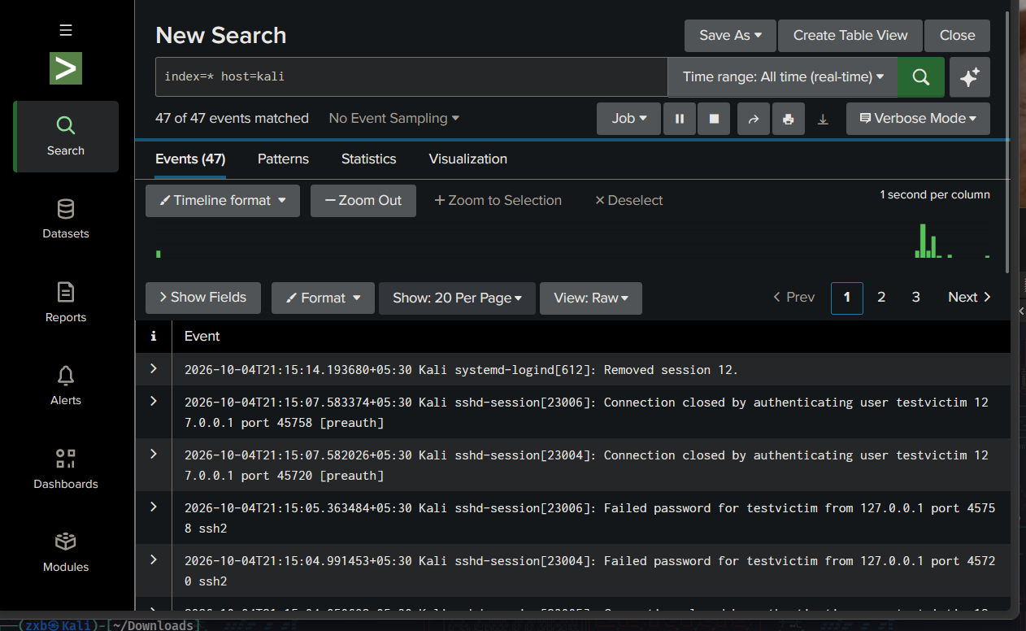
Splunk's Search & Reporting interface showing 47 ingested events from the Kali forwarder, including the real sshd session logs generated by the Hydra attack, confirming end-to-end log delivery from VM to SIEM.

Figure A-4: Benign Login Activity Captured in Splunk
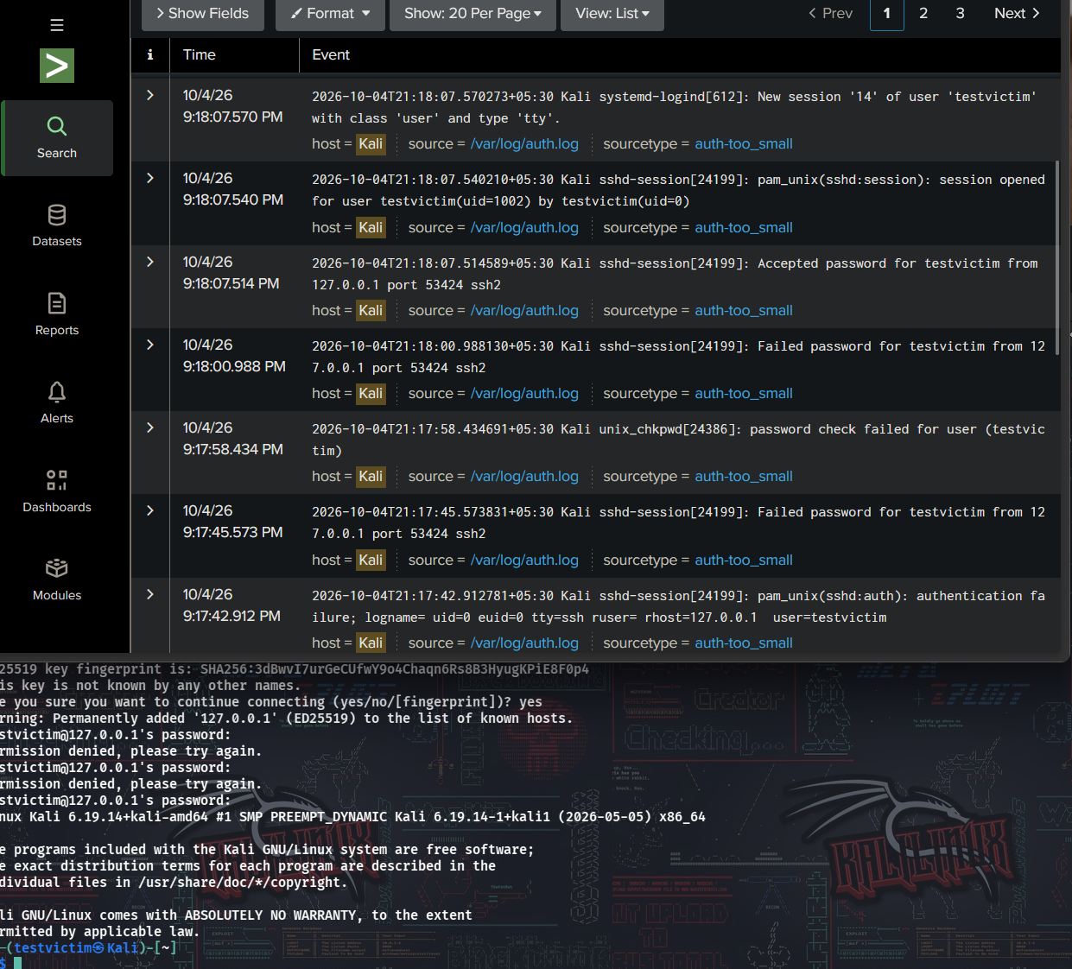
A broader Splunk search (76 events) showing both attack traffic and manually generated benign login attempts, including an invalid-username attempt ('Invalid user nouser') used to simulate a realistic typo scenario.

Figure A-5: Detection Query Applied to Captured Data
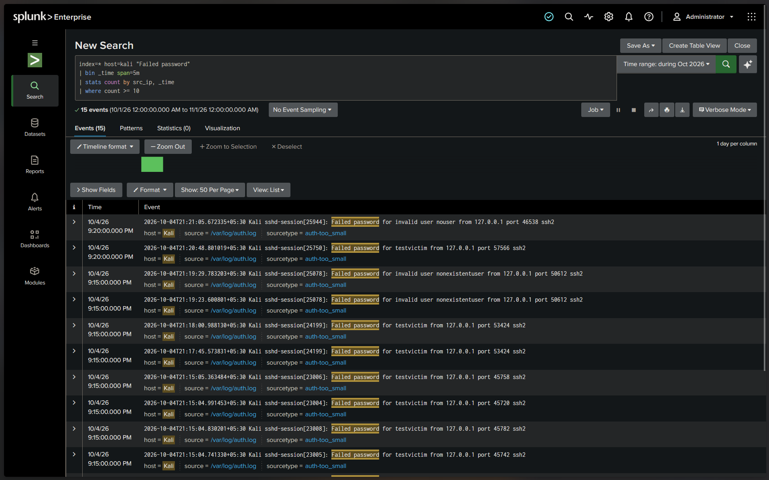
The SPL detection query (Section 5.5) applied against the dataset, isolating 'Failed password' events for further aggregation by source IP and time window.

Figure A-6: Aggregated Statistics — Failed Logins per Time Window
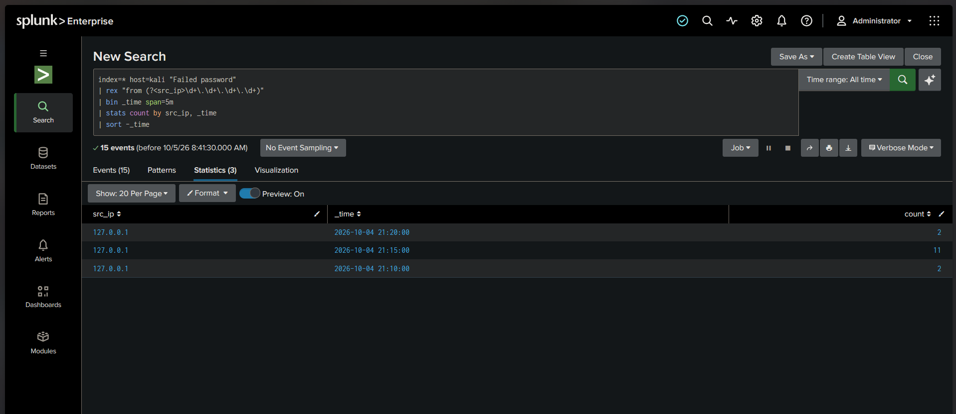
Splunk's Statistics tab showing the stats count by src_ip, _time aggregation, revealing the three key data points (2, 11, and 2 failed attempts) that first demonstrated a measurable gap between benign activity and the Hydra attack burst.

Figure A-7: Complete Dataset with Success/Failure Correlation
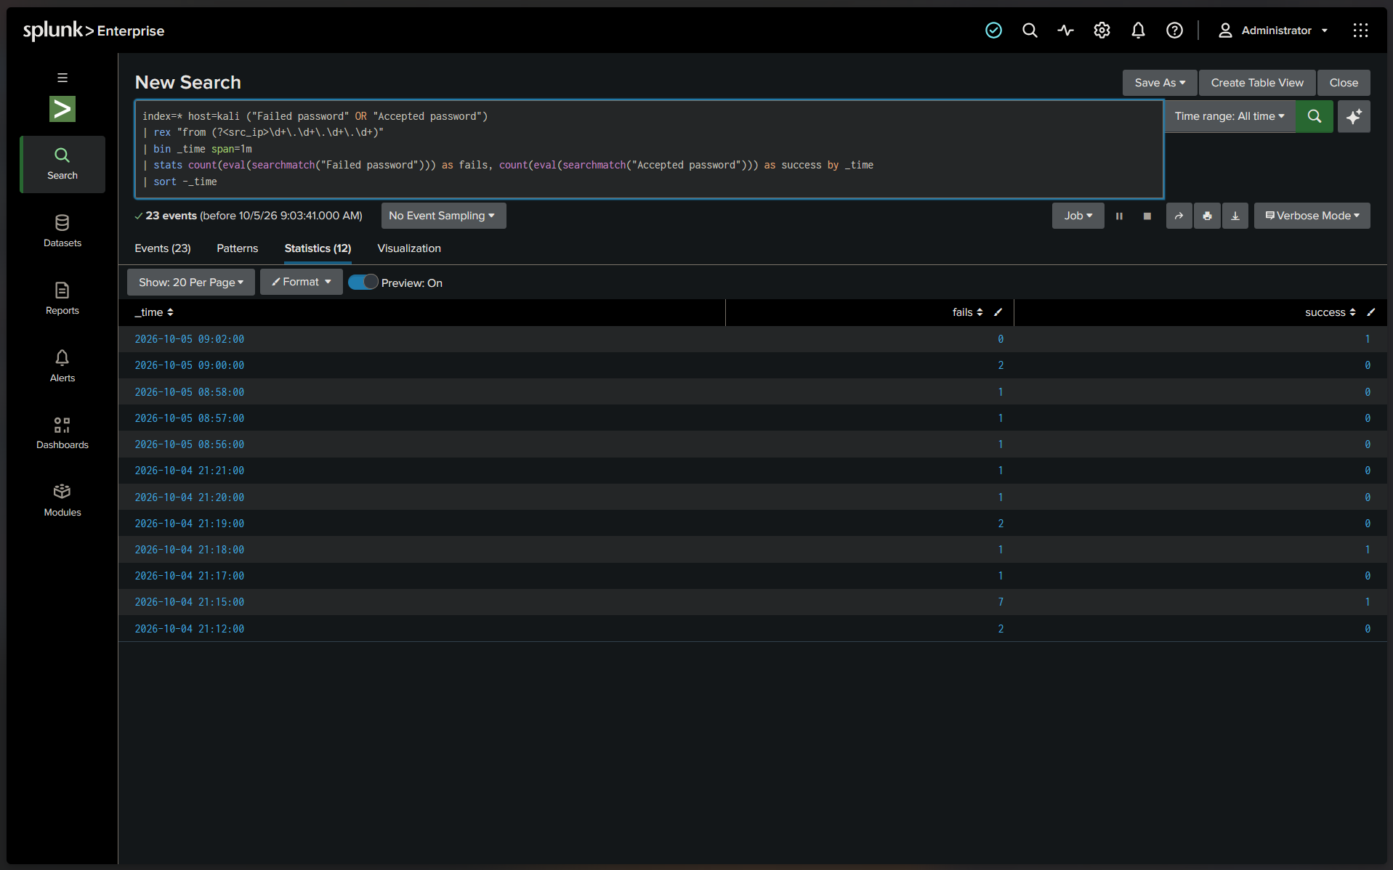
The final aggregated dataset (Section 6, Table 1) combining failed and successful login counts per time window across all benign and attack trials, used to generate Figures 1 and 2 in the main body of this report.

